**DOCTOR**

**PROJECT GROUP MEMBER**

|  |  |
| --- | --- |
| **Students Id** | **Students Name** |
| ***Student1449863*** | ***M.ADEEL CHOWDHRY*** |
| ***Student1452450*** | ***M.ALI*** |
| ***Student1413553*** | ***MURTAZA*** |
| ***Student1450989*** | ***ABDUL SAMAD*** |

**CURRICULUM BATCH**

**7062 2301C2**

**FACULTY**

**SIR HARIS NASEER**

**CO-ORDINATOR**

**MISS MAHA HAIDER**

**CERTIFICATE**

This is to certify that the dissertation entitled **“DOCTOR”** is

***M.ADEEL CHOWDHRY* *Student1449863*,**

***M.ALI*  *Student1452450*,**

***MURTAZA* *Student1413553 and***

***ABDUL SAMAD Student1450989***

in their partial fulfilment of the requirement of the award of the Aptech Computer Certified.

**ADMIN PANEL:**

**ADMIN LOGIN**

Here You can Login in Your Admin Account.

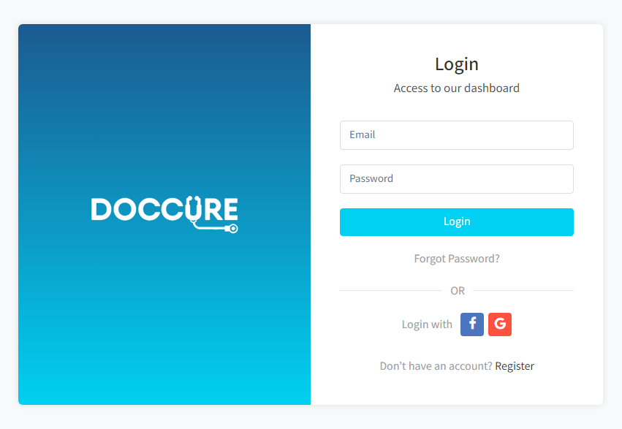

**HOME:**

Admin can read the details of login users.

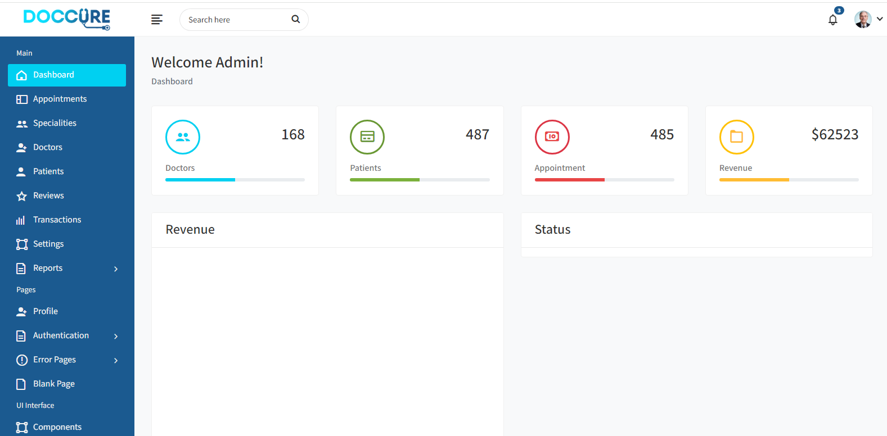

**PATIENTS:**

This is a patient list. where you can saw all patient

details..

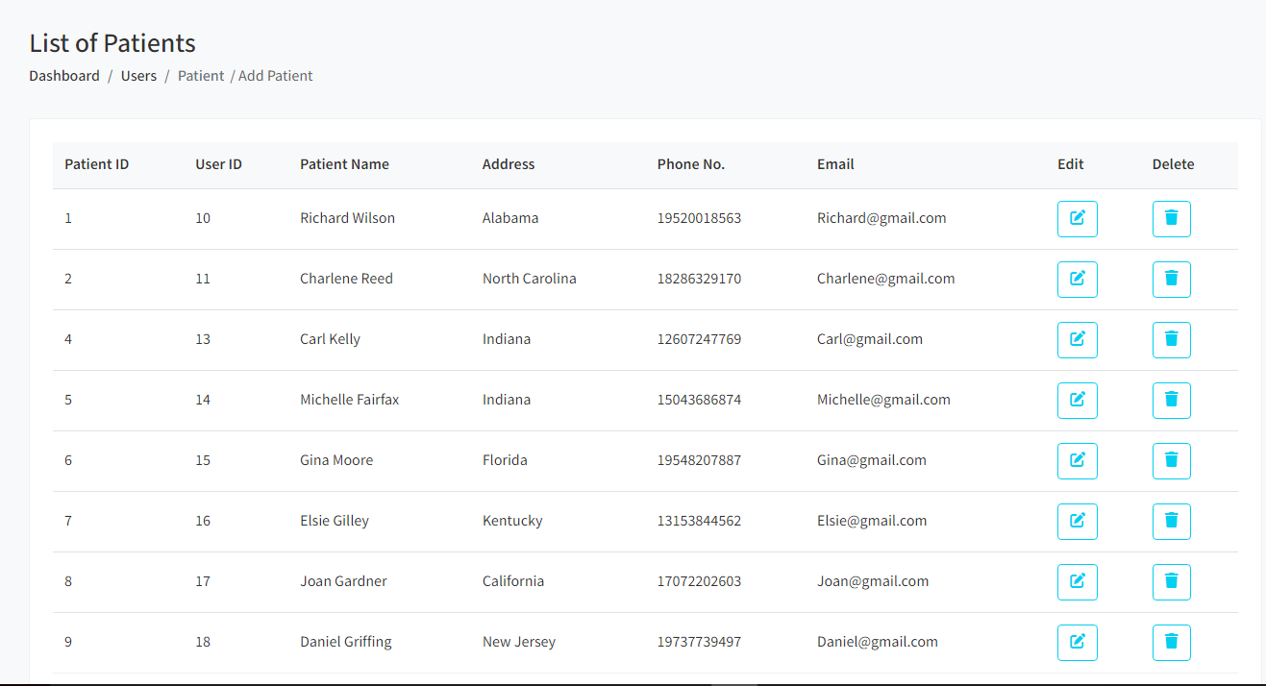

**SPECIALITES:**

SPECIALITES list are available here.

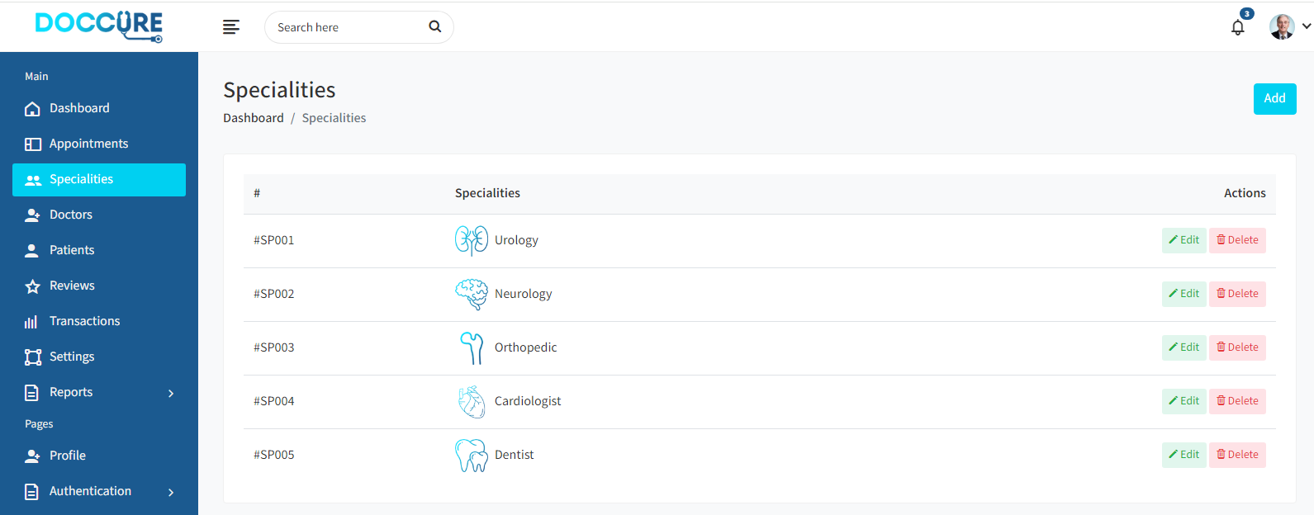

**REVIEWS:**

Here is a REVIEWS List.

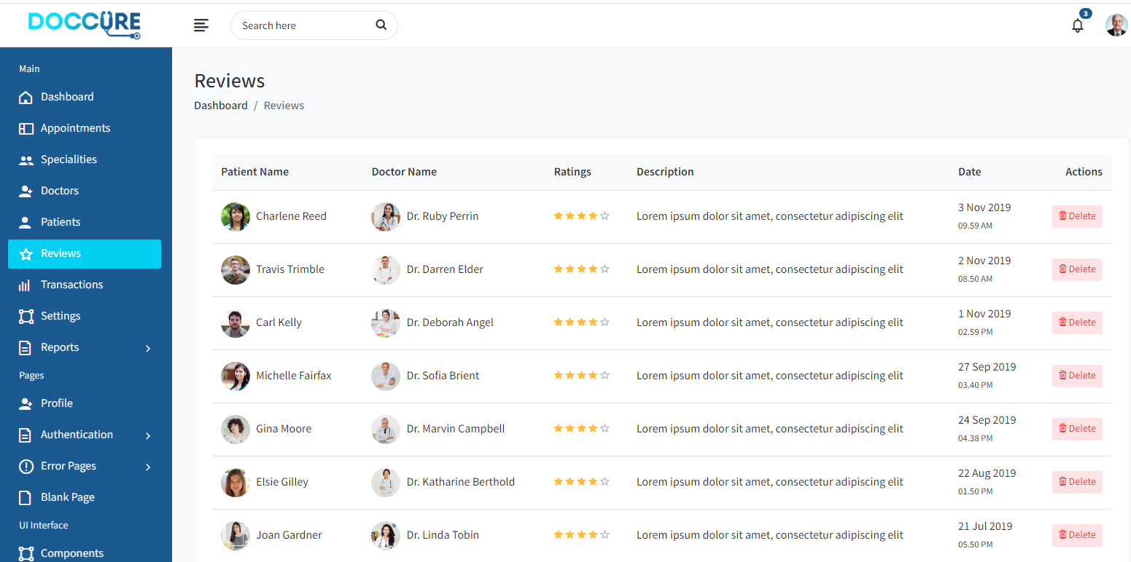

**APPOINTMENT:**

Appointment list you can easily saw there.

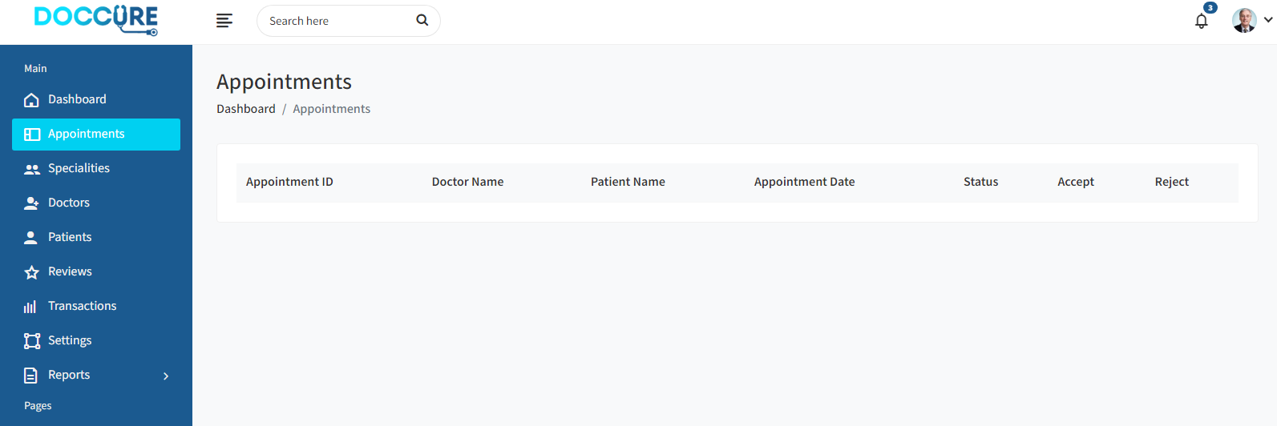

**DOCTOR LIST:**

DOCTOR LIST.

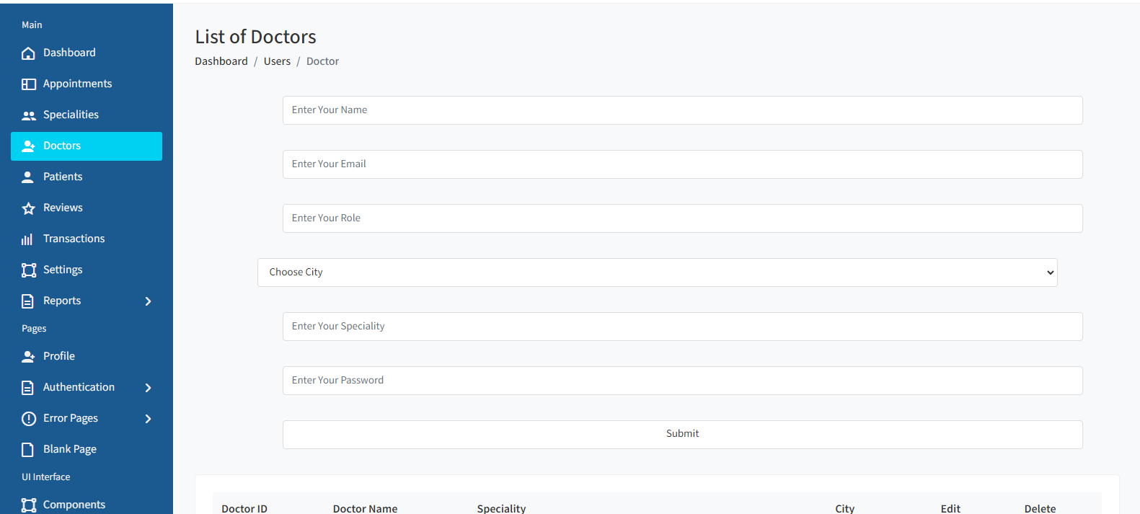

**APPOIINTMENT LIST:**

Appointment LIST..

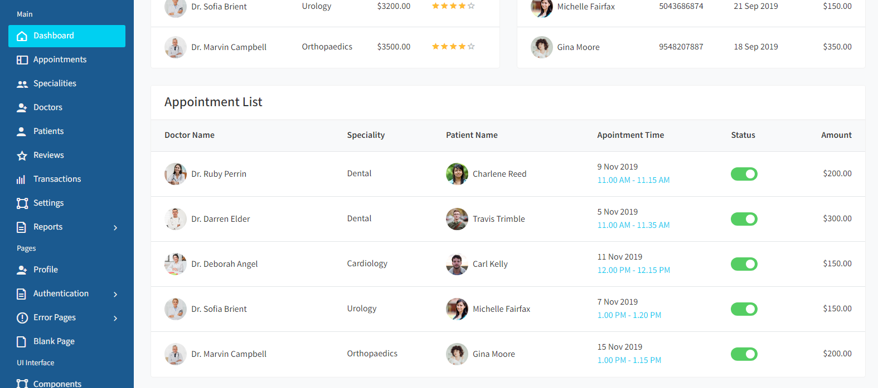

**INVOCE REPORT:**

INVOCE REPORT.

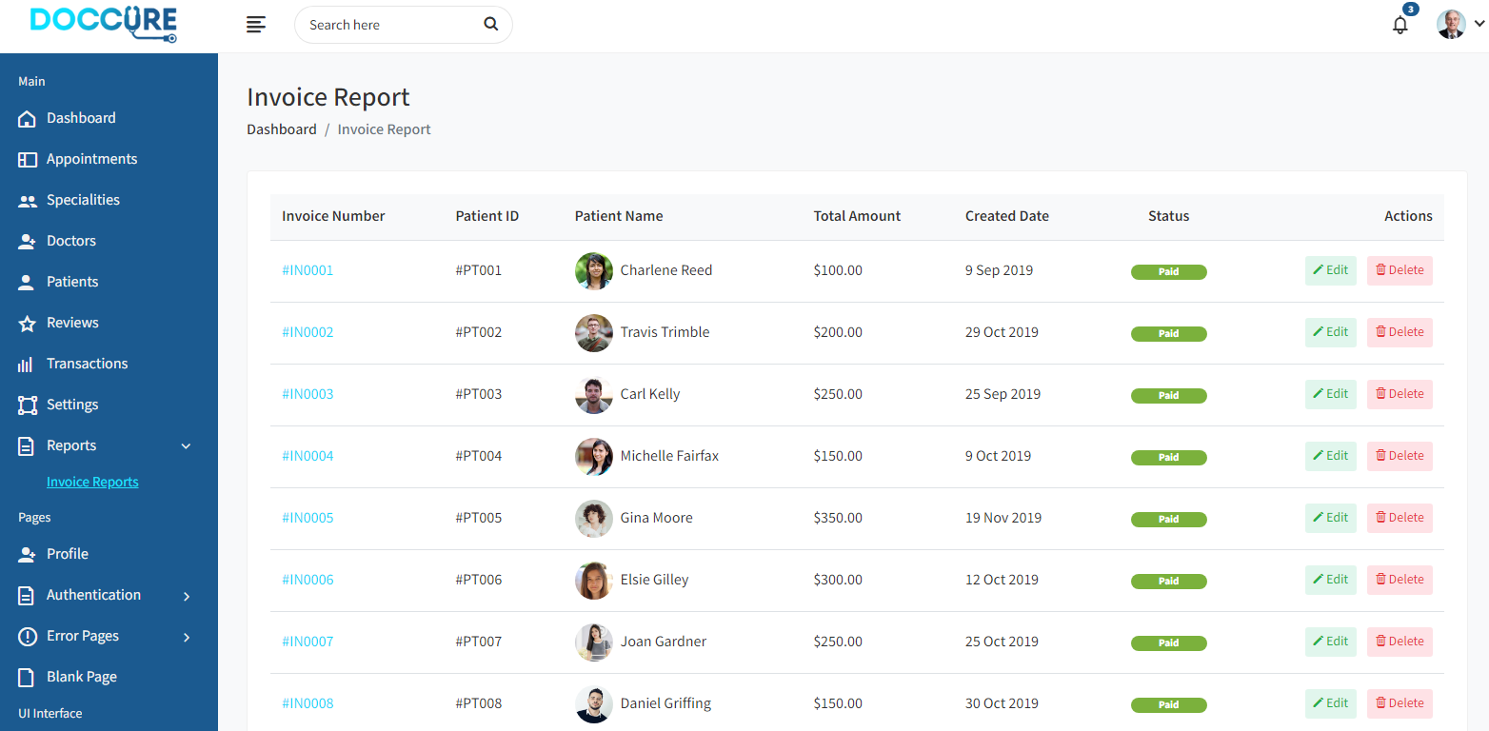

**CHANGE PASSWORD:**

Here is changing password option too.

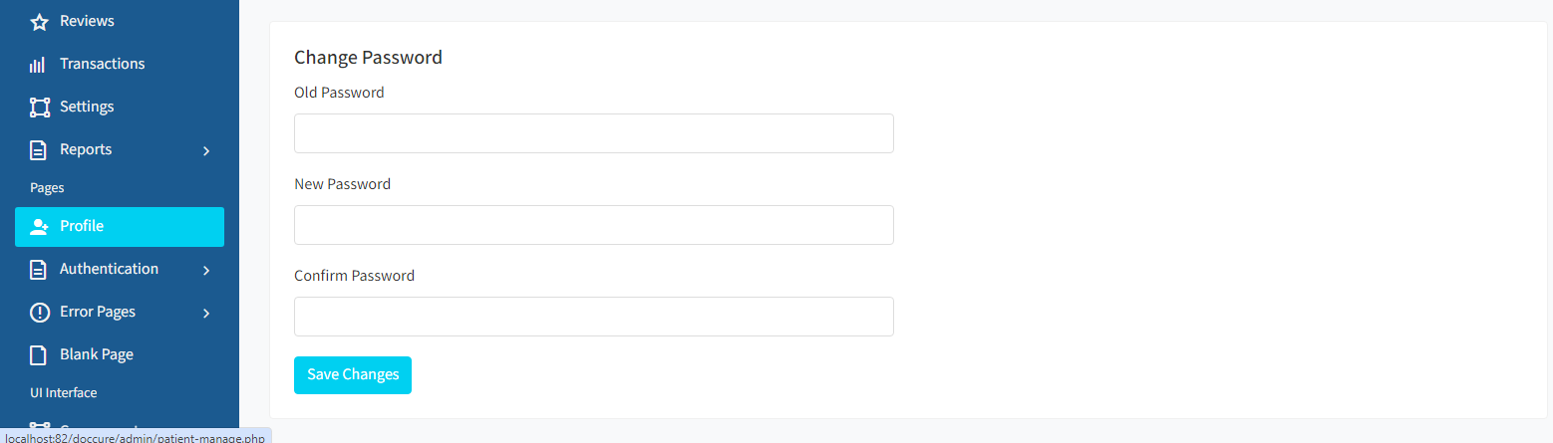

**PROFILE:**

Here you can update details you’re profile data.

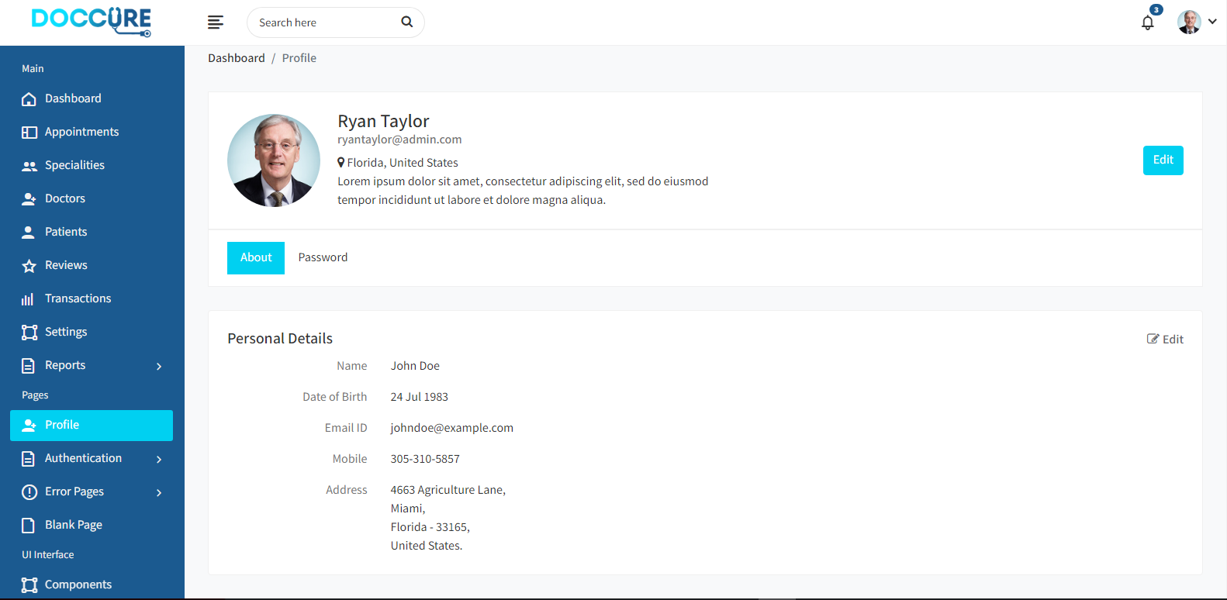

**ADMINHEADER/SIDEBAR:**

Here you can saw you’re all details related admin panel.



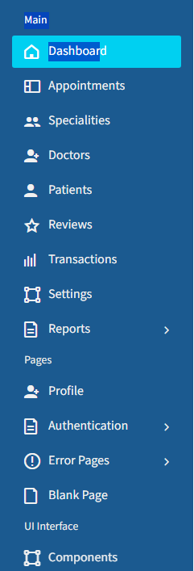

**DOCTOR REGISTER PANEL:**

DOCTOR Register page

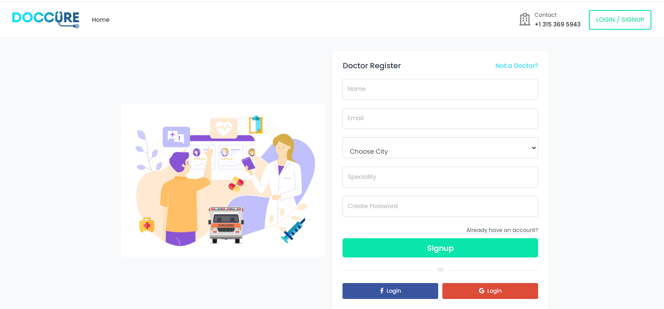

**DOCTOR LOGIN PANEL:**

DOCTOR Login page

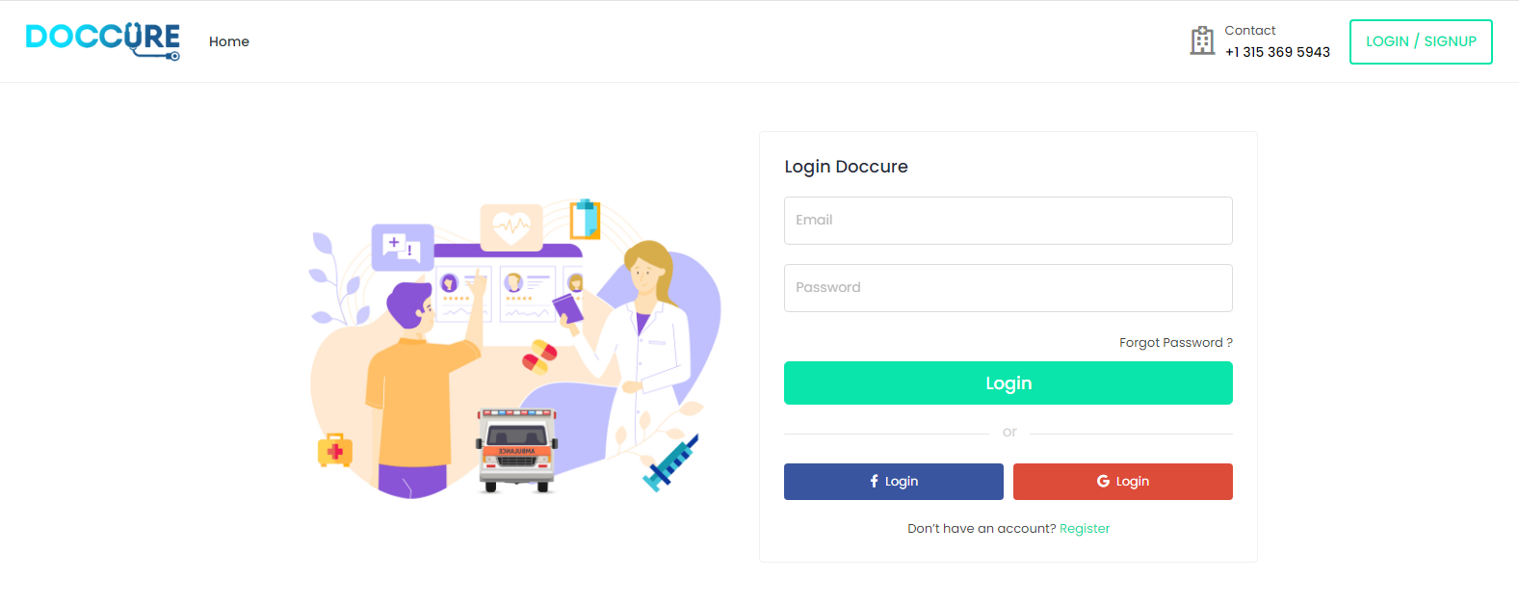

**DOCTOR DASHBOARD:**

DOCTOR dashboard.



